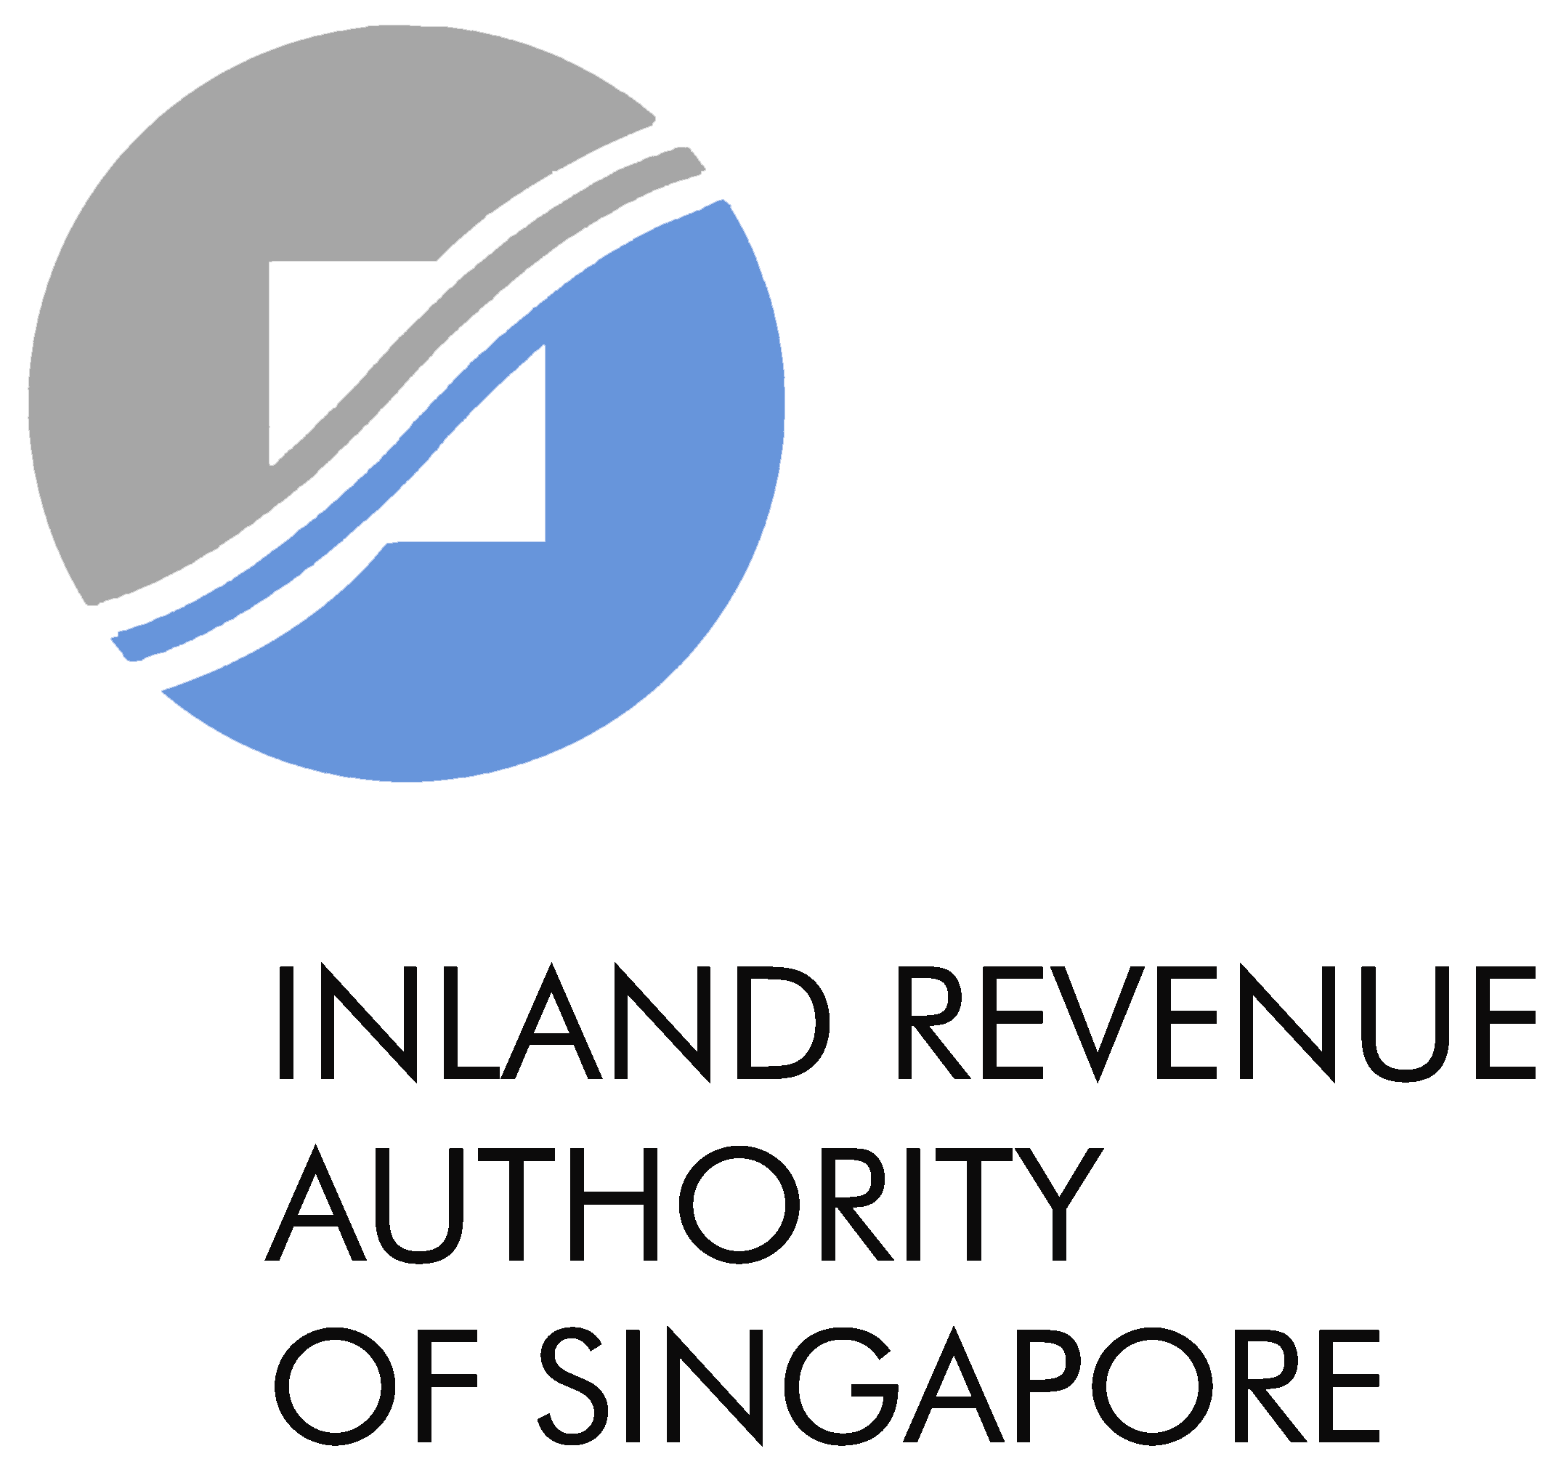

GST F18

Application for Remission under Section 89 of the GST Act for

Refund of Import GST paid on behalf of An Importer

The Comptroller of Goods and Services Tax
55 Newton Road, Revenue House, Singapore 307987
Tel: 1800 - 356 8633
For more information, please visit IRAS website at https://www.iras.gov.sg
Important Notes:
- This application may take 10 minutes to complete.
- Remission is available only to GST-registered freight forwarders / logistics agents who are unable to recover the import GST paid on behalf of importers. The GST must be paid on or after 1st Nov 2007 and all the conditions listed below are satisfied.
- This application is subject to the Comptroller of Goods and Services Tax’s approval and satisfaction of the documentary evidence. Conditions could be imposed in granting the remission.
- Please send us the completed application and copies of the documents listed in Section 5 below via myTax Portal [select “Email Us (myTax Mail)”]. Do not send this application via post or email.
- Once your application has been processed, IRAS will send you an SMS or email notification to the mobile number or email address provided in the application form. You will need to log in to myTax Portal (select “View Notices”) to view or download the letter.

Please complete the form in BLOCK LETTERS and indicate ‘NA’ where not applicable.

Section 1: Freight Forwarder / Logistics Agent’s Particulars

GST Registration Number
Unique Entity Number (UEN)
Full name of the Applicant

Section 2: Importer’s Particulars

GST Registration Number
Unique Entity Number (UEN)
Full name of Importer

Section 3: DECLARATION BY THE FREIGHT FORWARDER/LOGISTICS AGENT (ALL conditions must be satisfied)
I declare that I satisfy all the following criteria:
Yes
(a) I prepared import declaration for the goods in accordance with instructions received from the importer named in Section 2;
(b) I paid the import GST to Singapore Customs, on behalf of the importer, for the importation of the goods;
(c) I am unable to recover the import GST incurred from the importer;
Reason:
(d) I have re-exported the imported goods - unused - from Singapore; and
(e) I have control and custody over the imported goods while the goods were in Singapore.
Name of authorised person :
Designation : |  | Contact Number :
Email : |  | Signature :

Section 4: Declaration by the importer
I declare that I satisfy the following criterion:
Yes
(a) I have not claimed and will not claim the import GST that my freight forwarder / logistics agent
is requesting a refund of, as listed in Section 6 below.
Name of authorised person :
Designation : |  | Contact Number :
Email : |  | Signature :
Section 5: Documents and Records To Be Maintained By Freight Forwarder/Logistics Agent For At Least 5 Years
I have and will maintain original copies of the documents and records listed below to support
my claim for a refund of the import GST under this application as listed in Section 6 below.
Yes

a. invoice, GST payment permit, AirWay Bill/ Bill of Lading in relation to the importation of the goods
b. evidence of payment made to Singapore Customs of the import GST, as listed in Section 6 below
c. invoice, export permit, AirWay Bill/ Bill of Lading in relation to re-export of the imported goods
d. all correspondences/communication between myself and the importer

Section 6: Details Of Import GST To Be Claimed
(Please only include items that have satisfied all the criteria)
Import Permit Number :
Name of Importer on the permit :
Importer’s Unique Entity Number (UEN) :
Brief description of the imported goods :
Value of the imported goods  (as shown on the import permit) : | S$
Amount of import GST paid : | S$
Date of GST payment :
(If you are applying for refund of import GST on more than one GST payment permit, please provide the requested details on a separate page.)

