# **Where to find Reference Number or 14-digit Payment Slip Number?**

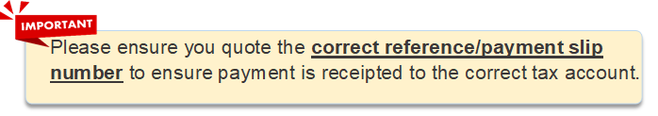

|  |  |
| --- | --- |
| **Content** | **Page No.** |
| **Individual Income Tax** |  |
| * Notice of Assessment | 2 |
| * Tax clearance Directive | 3 |
| * Employer Deduction Schedule | 4 |
| * Employer Deduction Payment slip | 5 |
|  |  |
| **Property Tax/Contribution Tax** |  |
| * Property Tax Bill | 6 |
| * SMS from IRAS | 7 |
| * Payment Slip | 8 |
|  |  |
| **Corporate Tax** |  |
| * Payment Slip | 9 |
| * Notice of Assessment | 10 |
|  |  |
| **Goods and Services Tax** |  |
| * GST F5 Return Acknowledgment | 11 |
|  |  |
| **Withholding Tax** |  |
| * IR37 Acknowledgment Form | 12 |
|  |  |
| **Stamp Duty** |  |
| * Acknowledgment page | 13 |



# **Individual Income Tax - Notice of Assessment**

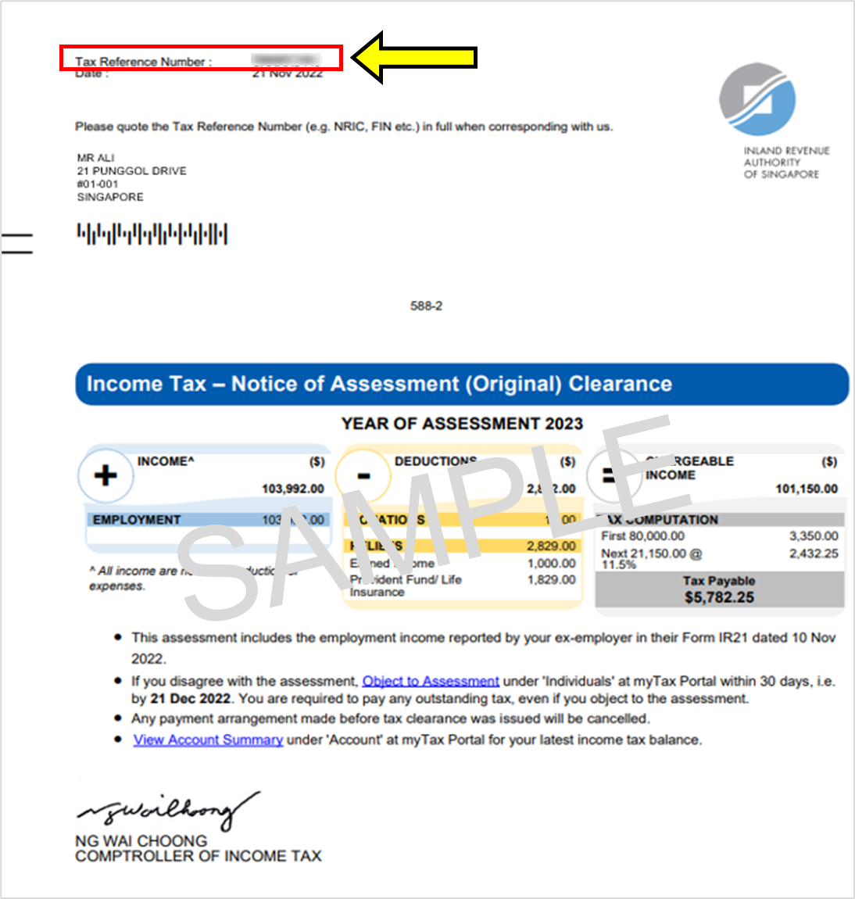



# **Individual Income Tax - Tax clearance Directive**

199000000A

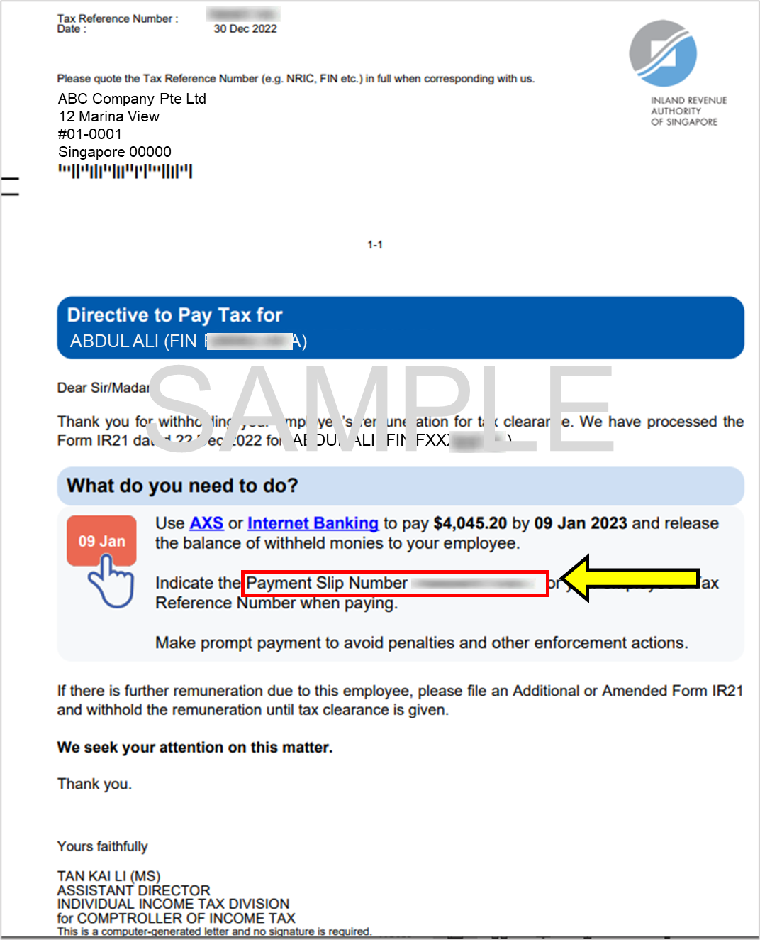



# **Individual Income Tax- Employer Deduction Schedule**

If you are **not paying** for **all the taxpayers listed** in the schedule, please **make individual payment for each employee**, and quote their Identification Number in the banking portal.

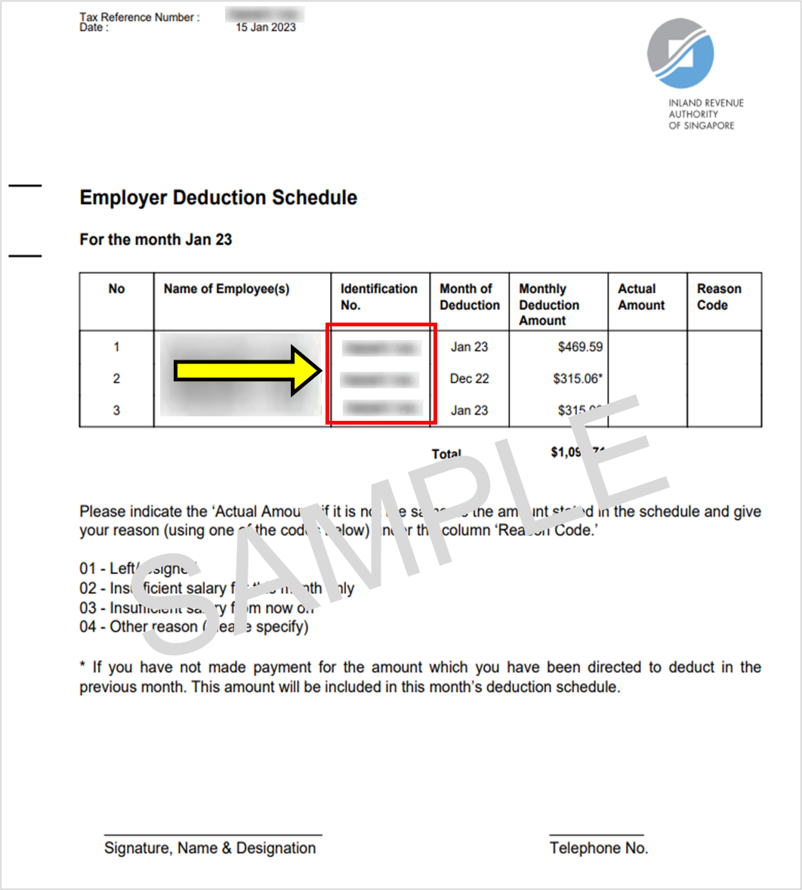



# **Individual Income Tax-Employer Deduction Payment Slip**

199000000A

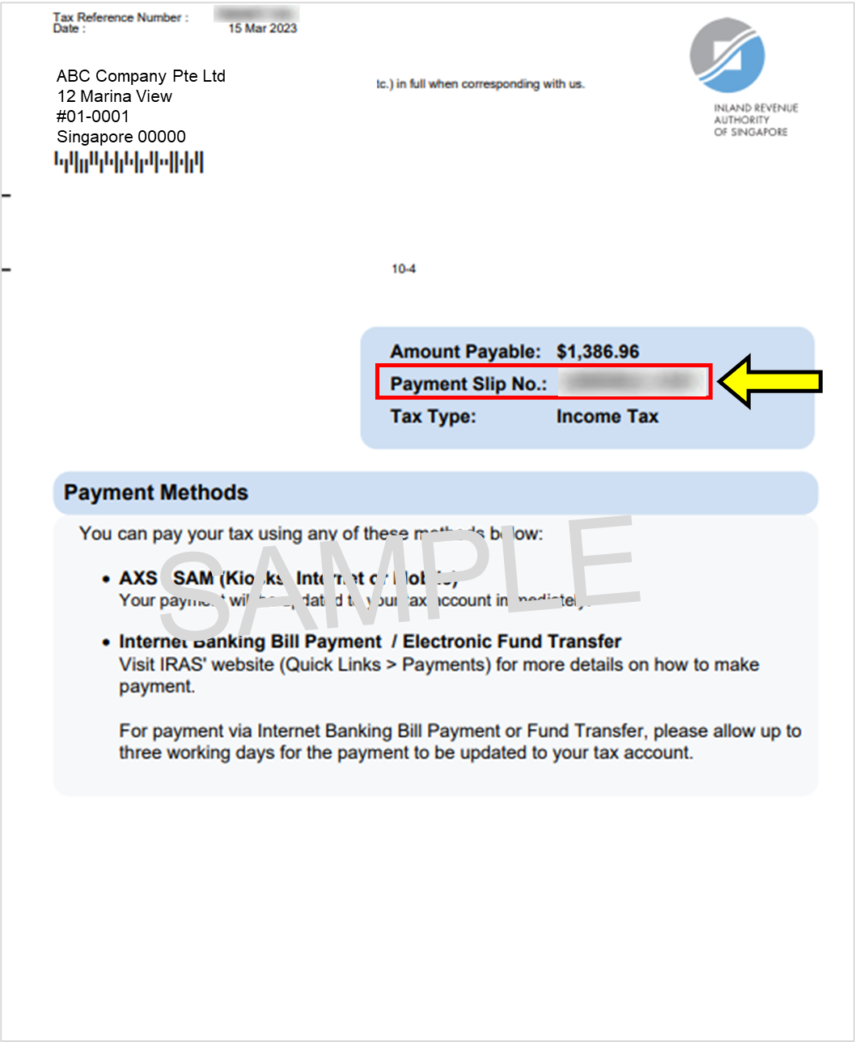



# **Property Tax- Property Tax Bill**

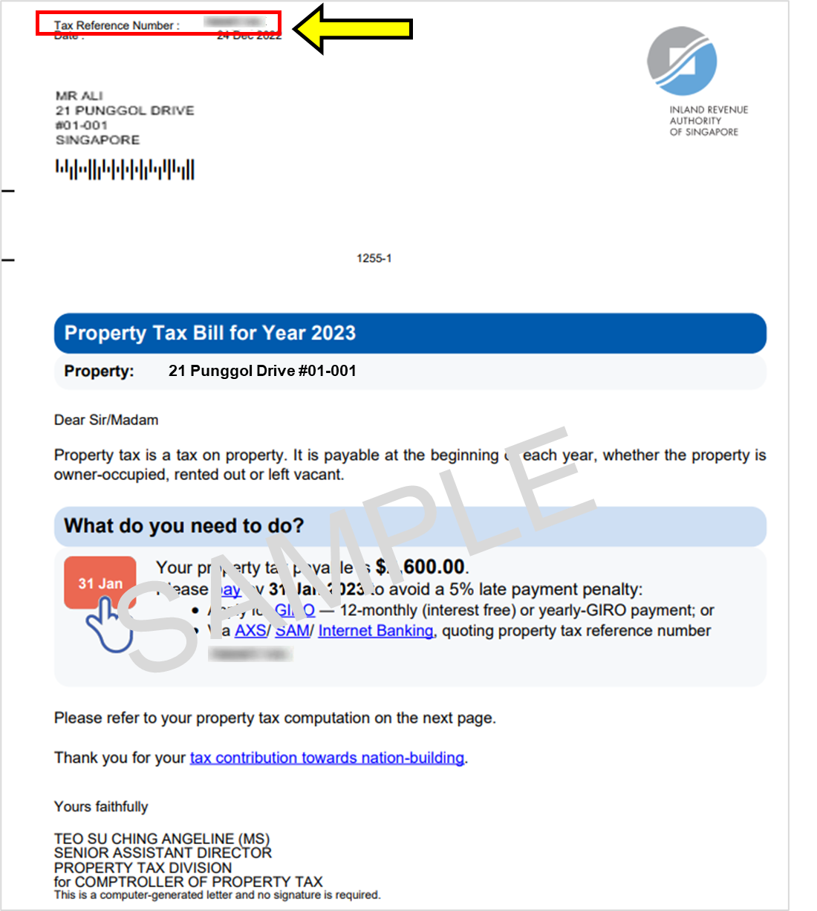



# **Property Tax- SMS from IRAS**

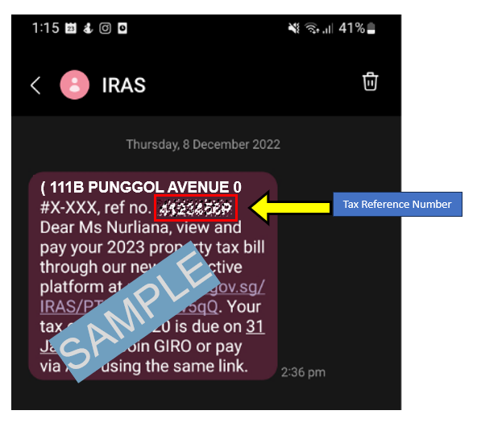



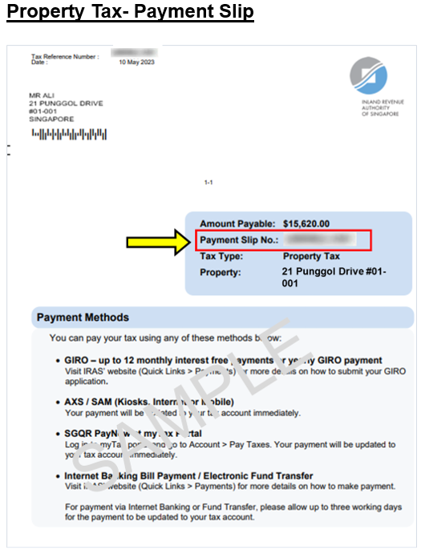



# **Corporate Tax – Payment Slip**

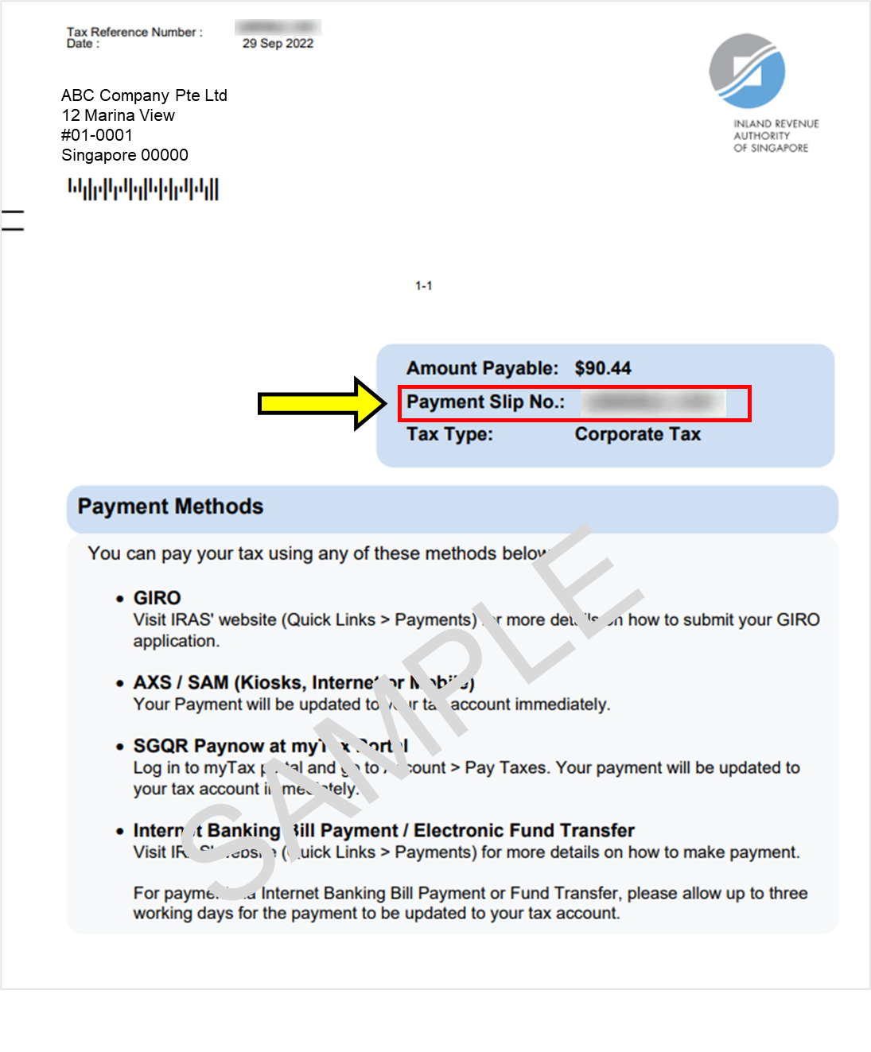



# **Corporate Tax - Notice of Assessment**

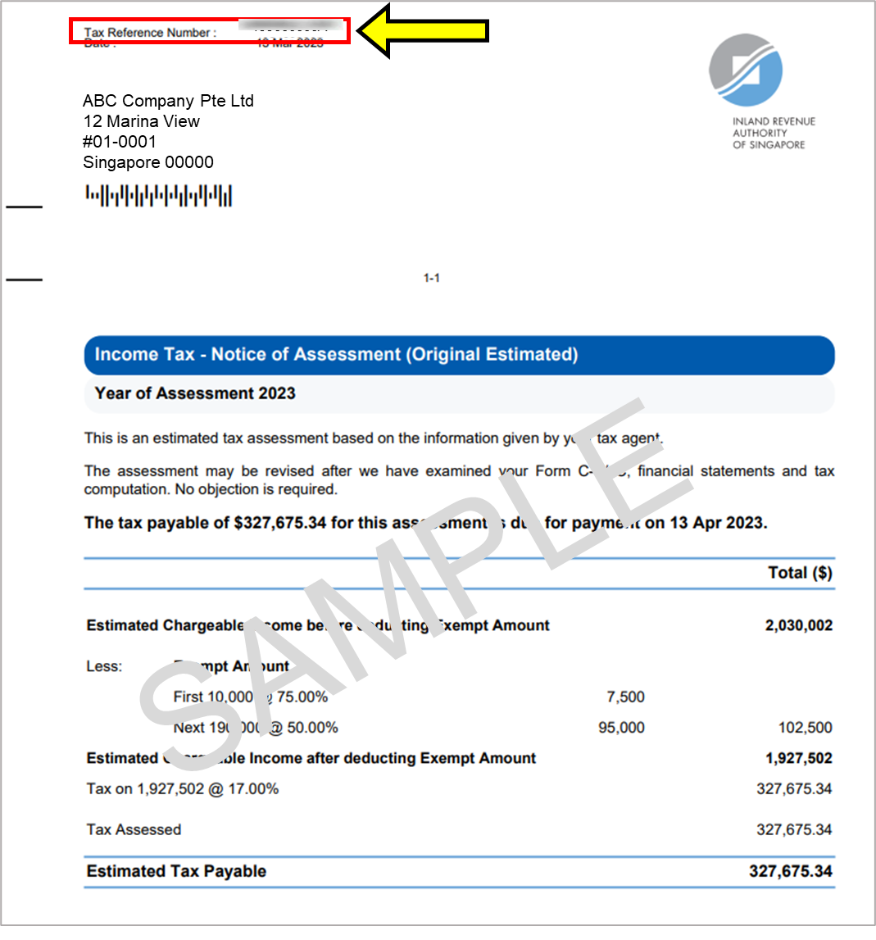



# **GST- F5 Return Acknowledgment**

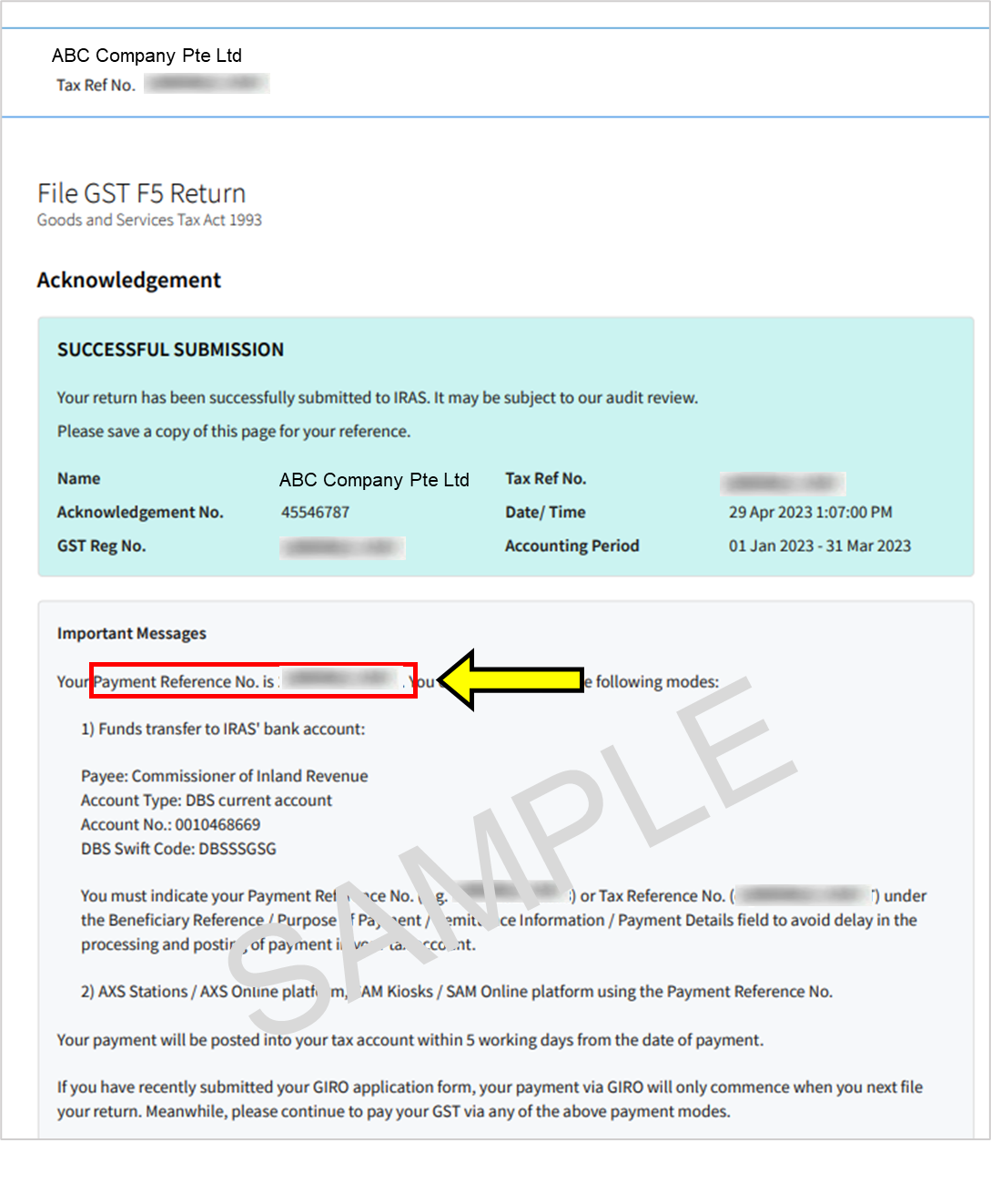



# **Withholding Tax- IR37 Acknowledgment Form**

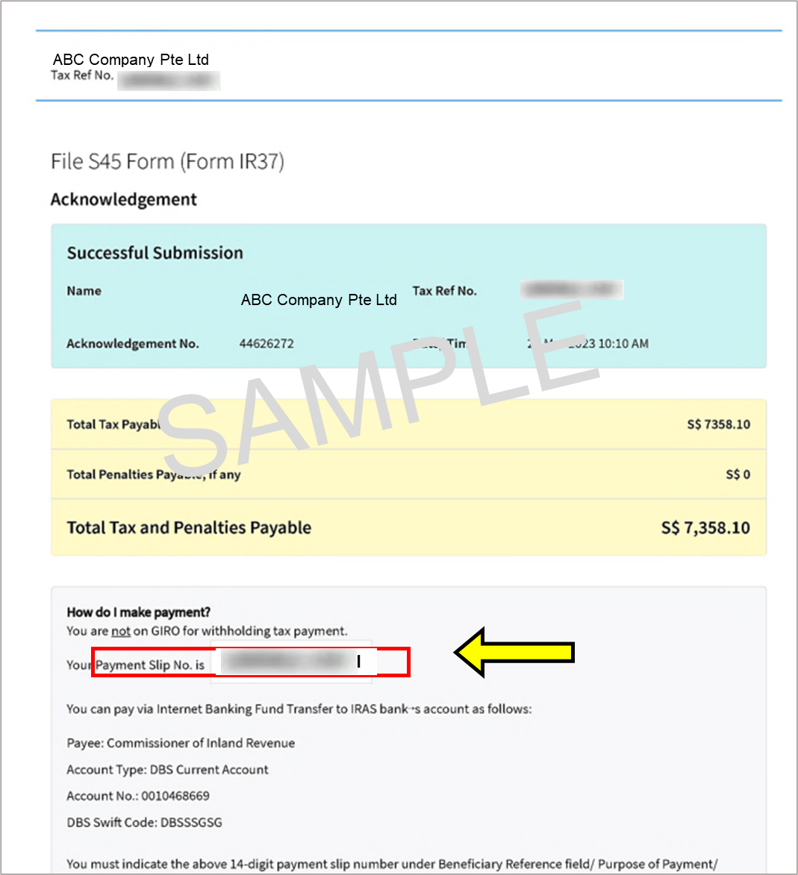



# **Stamp Duty-Acknowledgement Page**

